**The Oregon Trail with Python(s)**

**User Guide**

**SDEV265, Summer 2023**

**Red Team**

**Table of Contents**

**Introduction 3**

**Installation 4**

**Requirements 7**

**Character Selection 8**

**Game Play 9**

**Checkpoints 11**

**Resources 12**

**Game Ending 13**

**Summary 14**

# **Introduction**

Welcome to the Oregon Trail with Python(s)! This game puts you in the shoes of a pioneer traveling along the Oregon Trail, trying to make it to the next checkpoint before running out of food. Your decisions will determine the outcome of your journey. The game is designed for 1 player and may be launched on any desktop with a Python 3.0 or greater installation.

# **Installation**

To play the game, you'll first need to install Python on your system. Here are the steps to install Python and download the source code:

**Install Python:**

1. Visit the official Python website at https://www.python.org/.
2. Click on the "Downloads" tab and select the appropriate installer for your operating system (e.g., Windows, macOS, or Linux).
3. Download the latest version of Python 3.x.x (where x represents the specific version).
4. Run the installer and follow the instructions provided. Make sure to check the box that says "Add Python to PATH" during the installation process.

**Clone the repository:**

1. Open your preferred command-line interface (e.g., Command Prompt on Windows or Terminal on macOS/Linux).
2. Navigate to the directory where you want to store the game's source code.
3. Execute the following command to clone the repository:  
   git clone <https://github.com/Crstt/SDEV265_GroupRed.git>

**Access the game directory:**

1. Change your current directory to the "oregon-trail-python" folder within the cloned repository:

cd SDEV265_GroupRed/oregon-trail-python

1. Install the dependency with the following command “pip install -r .\requirements.txt.”

**Run the game script:**

1. Launch the game by executing the following command:

python oregon_trail.py

If you don't have Git installed or prefer not to use it, you can still download the source code for the Oregon Trail game directly from the GitHub repository. Here's an alternative method to download the source code:

**Visit the Oregon Trail GitHub repository:**

1. Go to the following URL in your web browser: https://github.com/Crstt/SDEV265_GroupRed.

**Download the source code as a ZIP file:**

1. On the repository page, click on the green "Code" button.
2. In the dropdown menu, click on "Download ZIP".
3. This will download the entire repository as a ZIP file to your computer.

**Extract the ZIP file:**

1. Once the ZIP file is downloaded, locate it on your computer and extract its contents to a desired location.
2. You can use a built-in ZIP extraction tool or a third-party software like 7-Zip or WinRAR.

**Access the game directory:**

1. Open the extracted folder that corresponds to the downloaded ZIP file.
2. Within that folder, navigate to the "oregon-trail-python" directory.
3. Install the dependency with the following command “pip install -r .\requirements.txt.”

**Run the game script:**

1. Open your preferred command-line interface (e.g., Command Prompt on Windows or Terminal on macOS/Linux).
2. Change your current directory to the "oregon-trail-python" folder you located in the previous step.
3. Execute the following command to start the game:

python oregon_trail.py

# **Requirements**

Python 3.0 or above: Ensure that you have Python 3.0 or a newer version installed on your system. You can verify the installation by running the command python --version in your command-line interface.

# **Character Selection**

Oregon Trail is a single player game. To get started, click the **Play the Oregon Trail!** button.

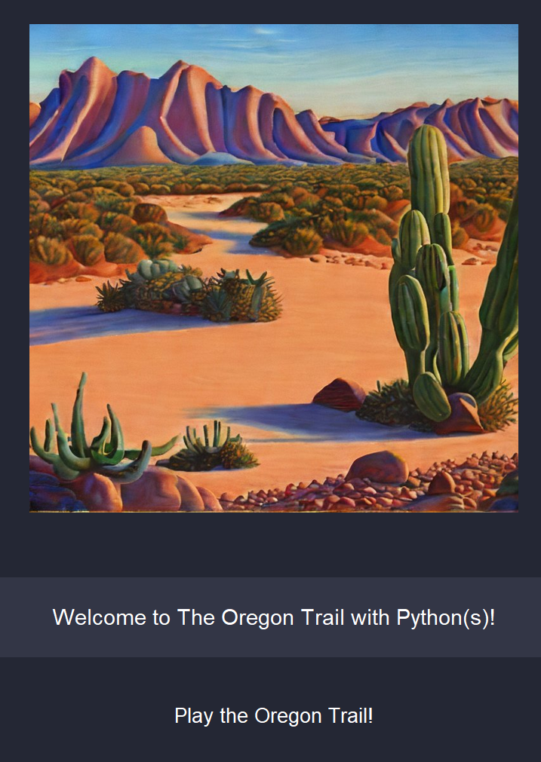

Oregon Trail provides 3 character options. Select the character you prefer to play as:

* **Banker** – Starts with the most money but has the lowest skills at surviving off the land.
* **Farmer** – Starts with the least amount of money but has the highest skills at surviving off the land.
* **Merchant** – Starts in the middle with money and survival skills. Gets a discount on purchases.

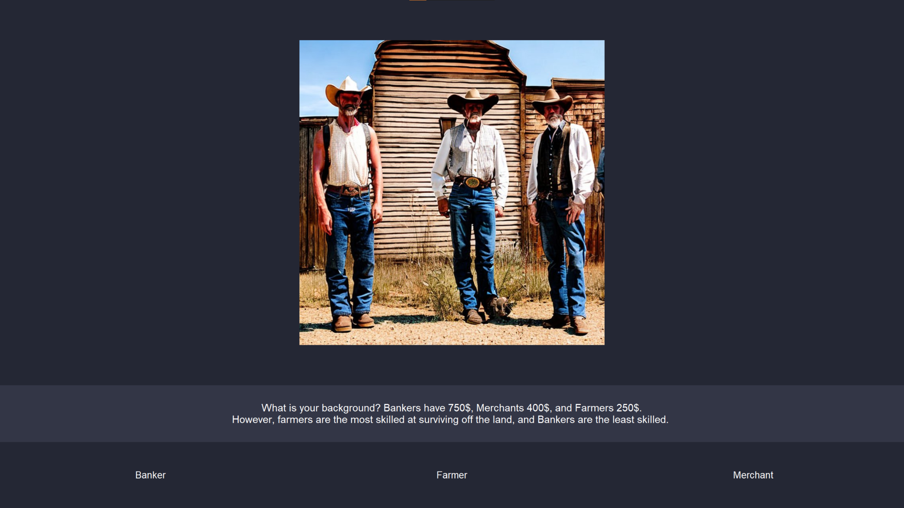

# **Game Play**

The game consists of traveling to your final destination with a few checkpoints along the way. Along your journey, you will be presented with a variety of scenarios.

After character selection you will travel your first day and the results of that day's travel will be presented.

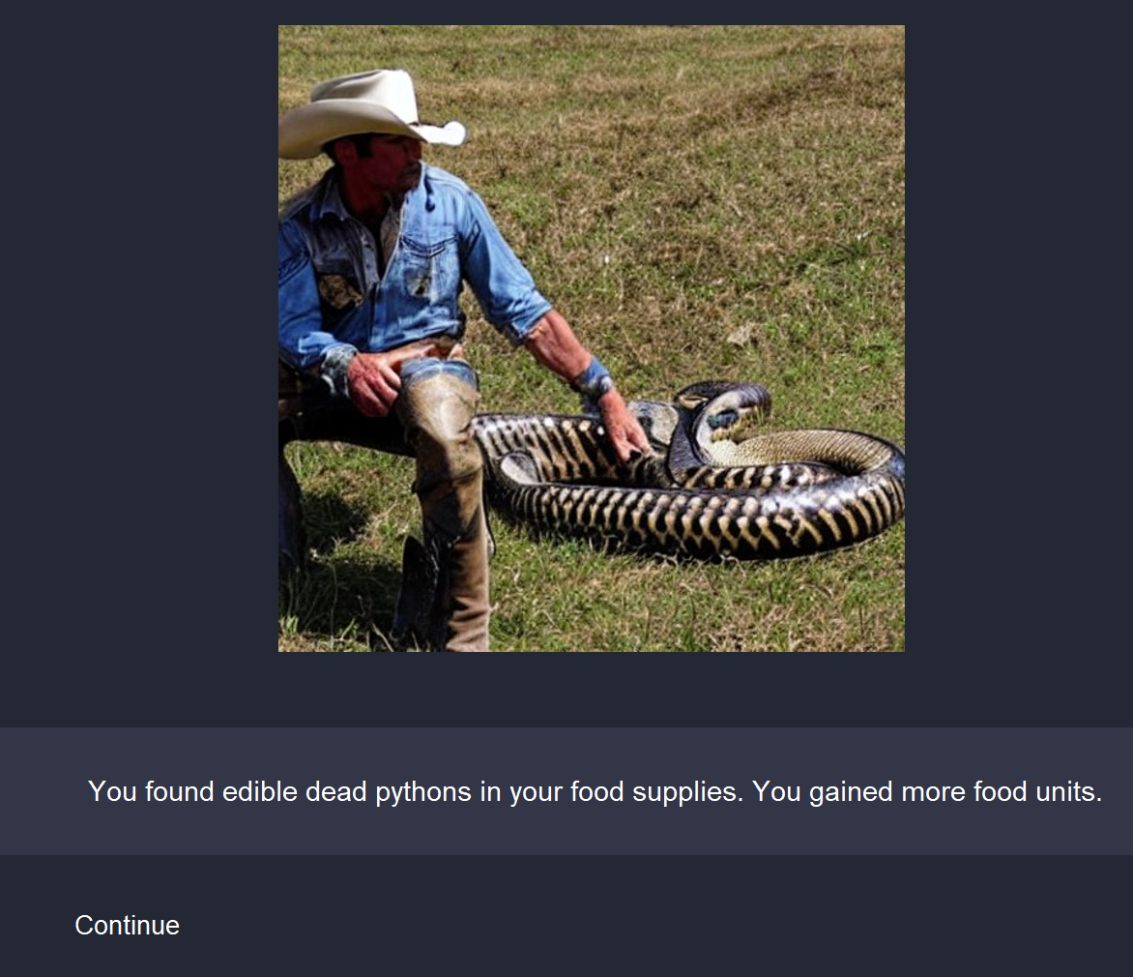

If the scenario does not require a choice by you, then you will have the option to continue your travel or to hunt for more food.

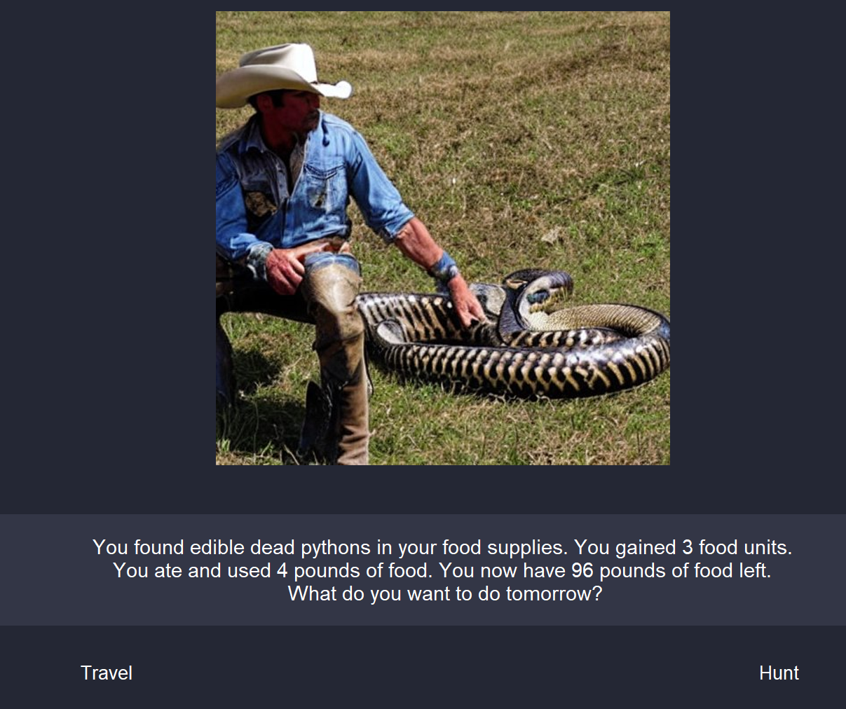

Some scenarios will require you to make a choice:

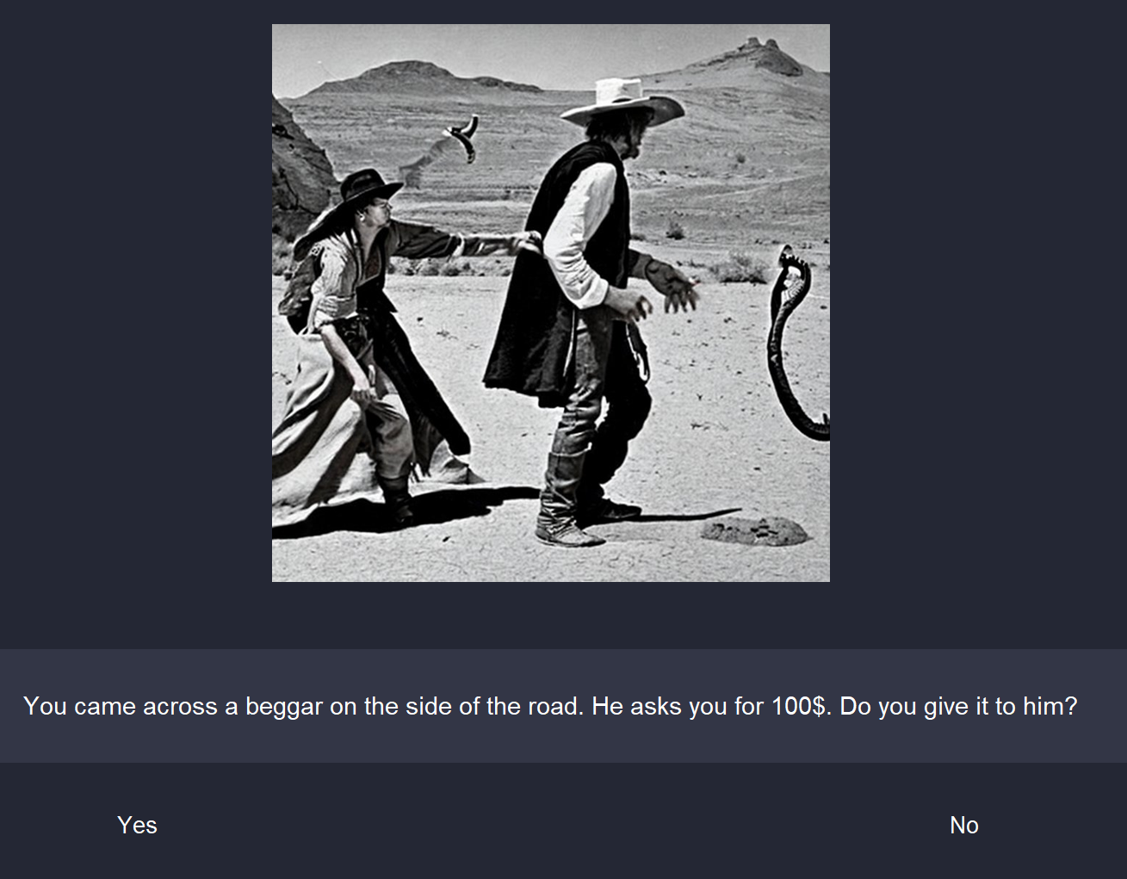

Select your choice to see the results and continue.

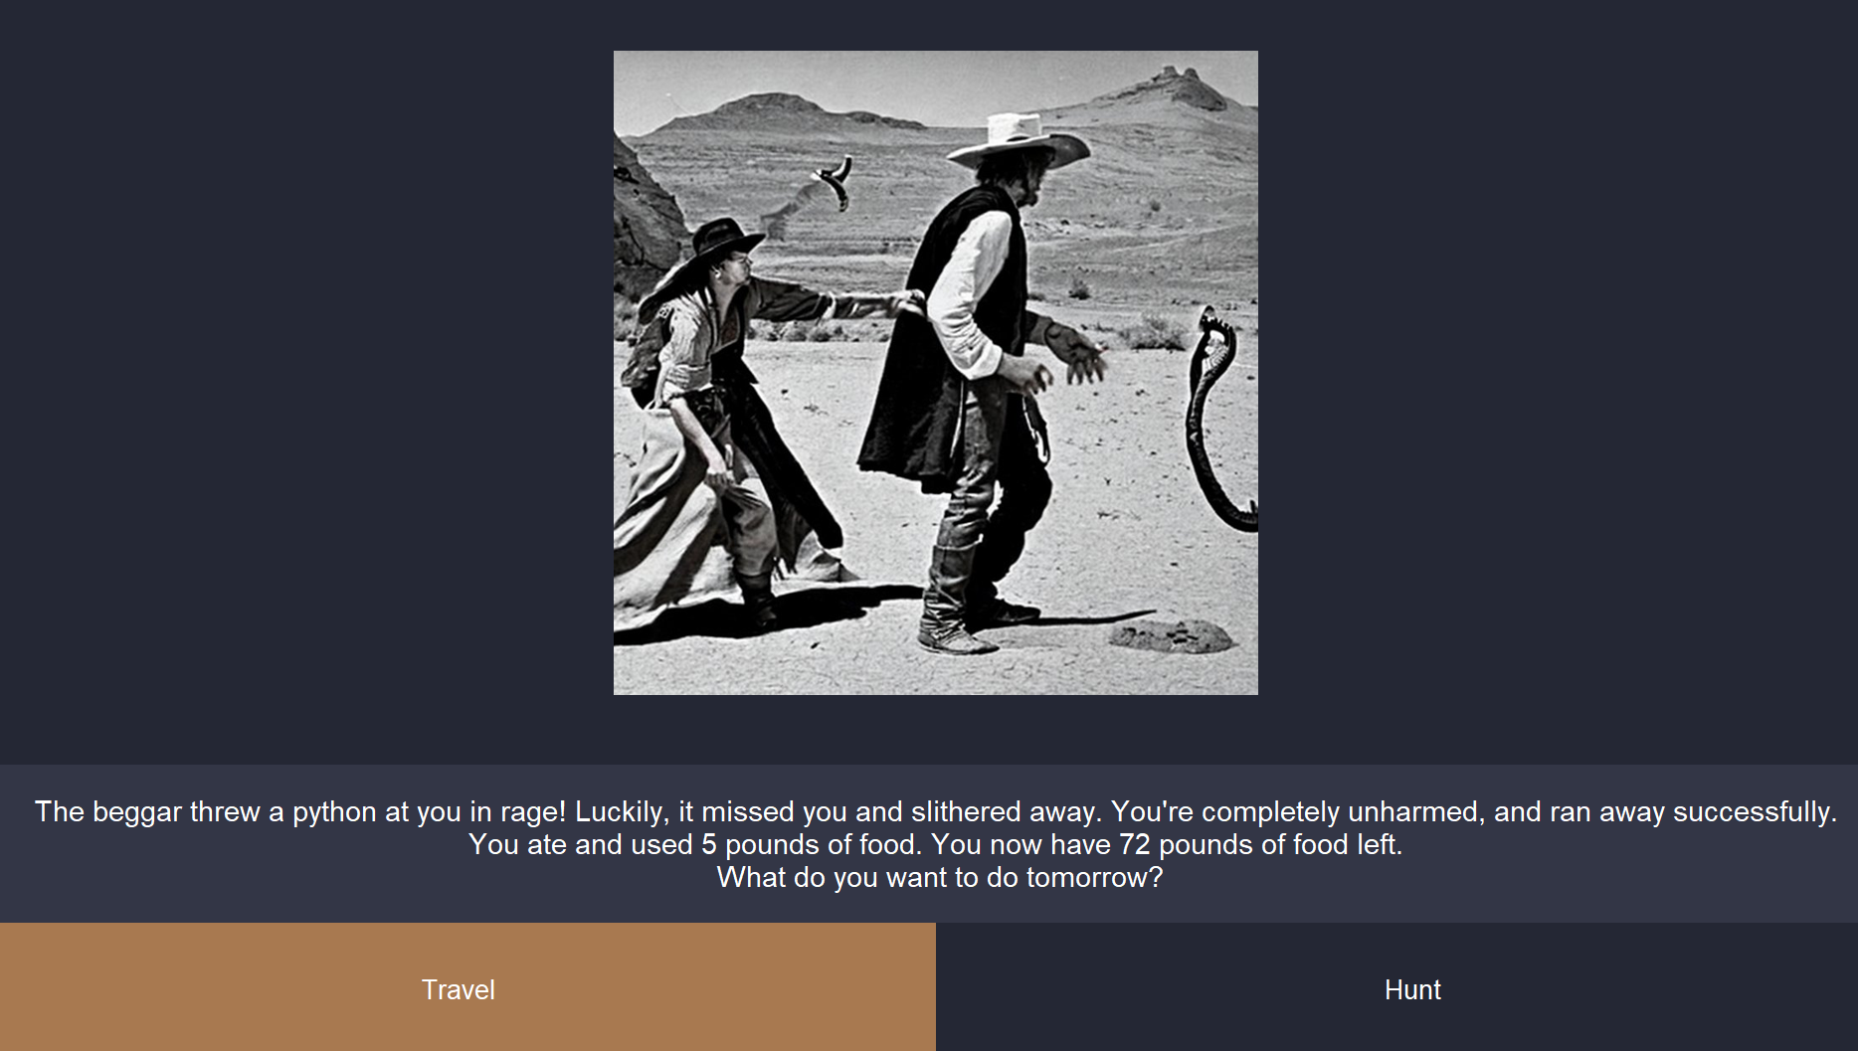

# **Checkpoints**

**Towns:**

At town checkpoints you will have the opportunity to purchase food with any remaining money you have or travel onwards..

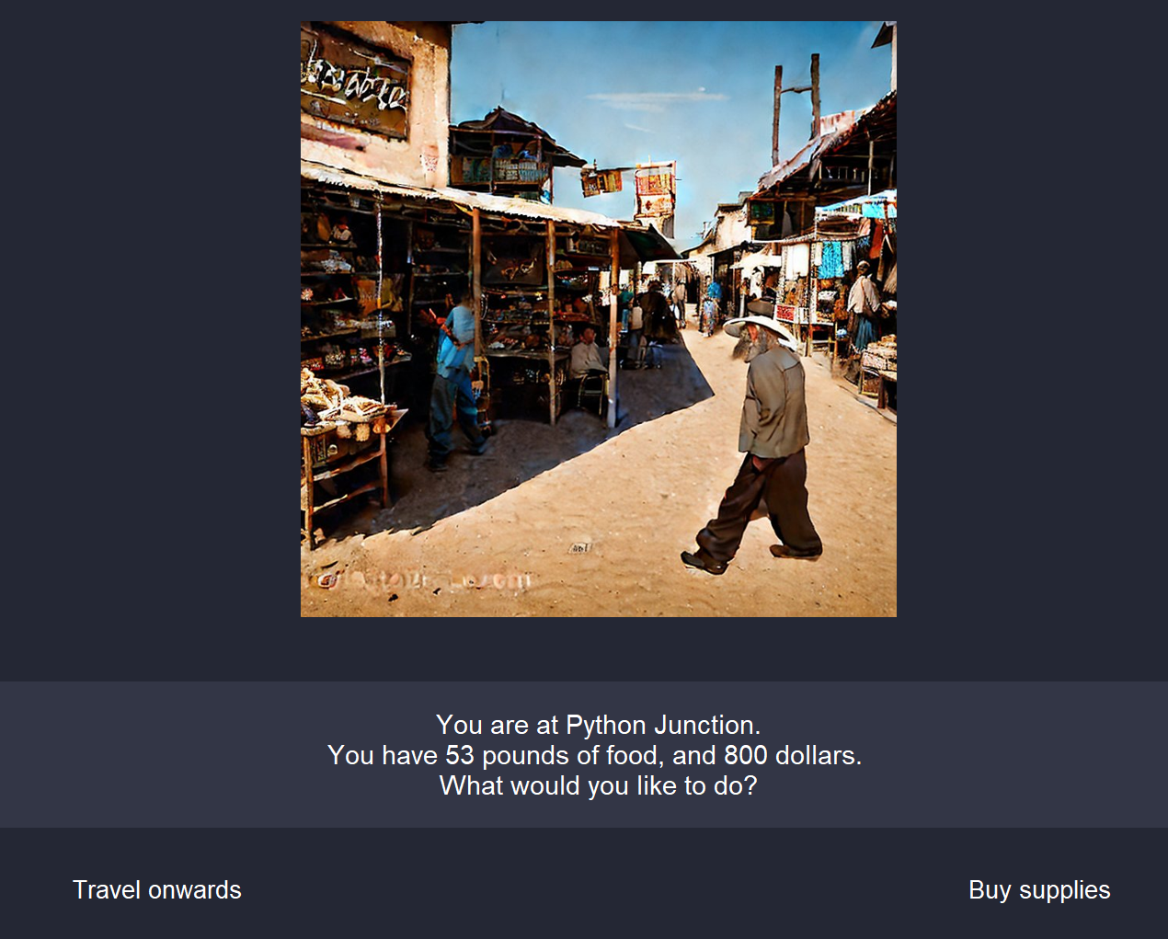

**River:**

At river crossings, you can attempt to ford the river or pay the ferry to cross.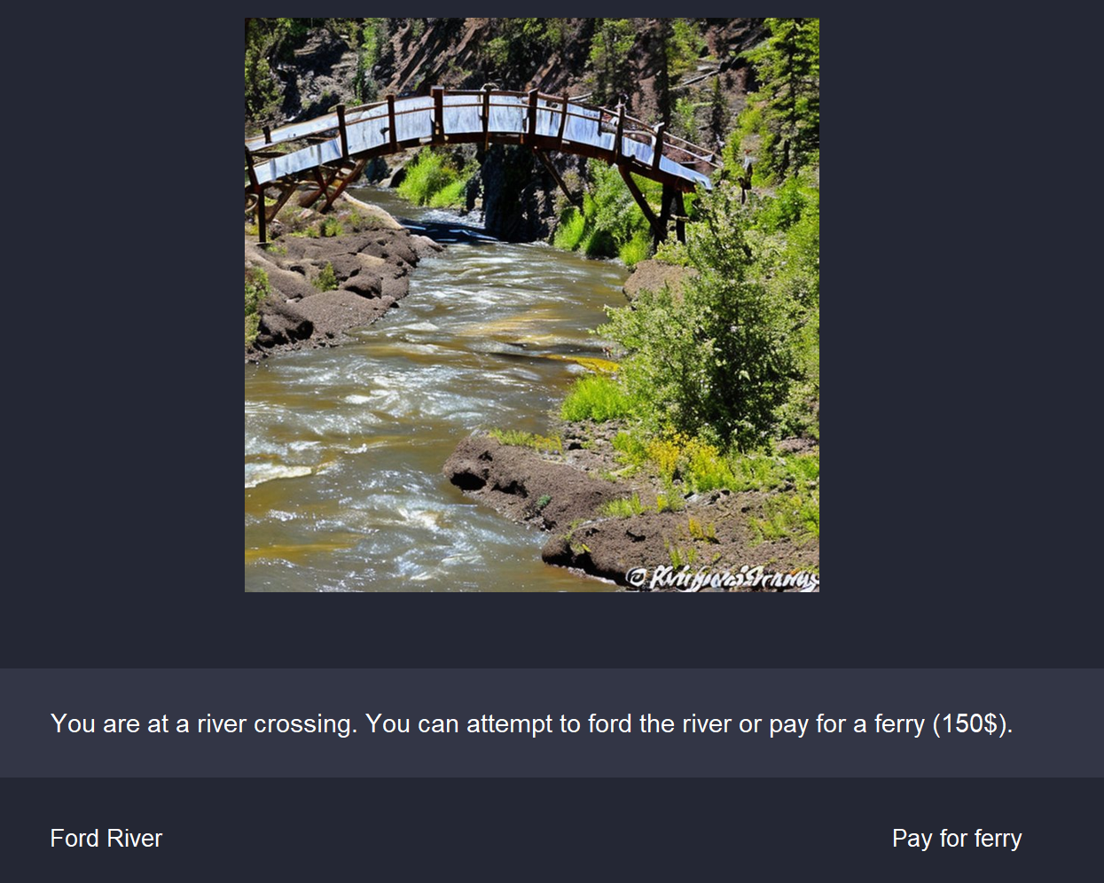

# **Resources**

**Money:**

Players start with a different amount of money depending on which character they choose at the beginning. Money is used to buy additional food, pay for river crossings, or to pay out in scenarios that offer it as an option. Additional money can only be gained through random luck from a scenario result.

**Food:**

Players start out with a different amount of food depending on the character they choose at the beginning. Food is consumed each day, regardless of the distance traveled. Running out of food results in starvation. Additional food can be purchased, hunted for, or acquired as the result of a scenario.

# **Game Ending**

**Death:**

The path of the Oregon Trail is a treacherous one. Sickness, injury, drowning, and starvation are always constantly at your heel. If one of those catches up to you it’s game over!

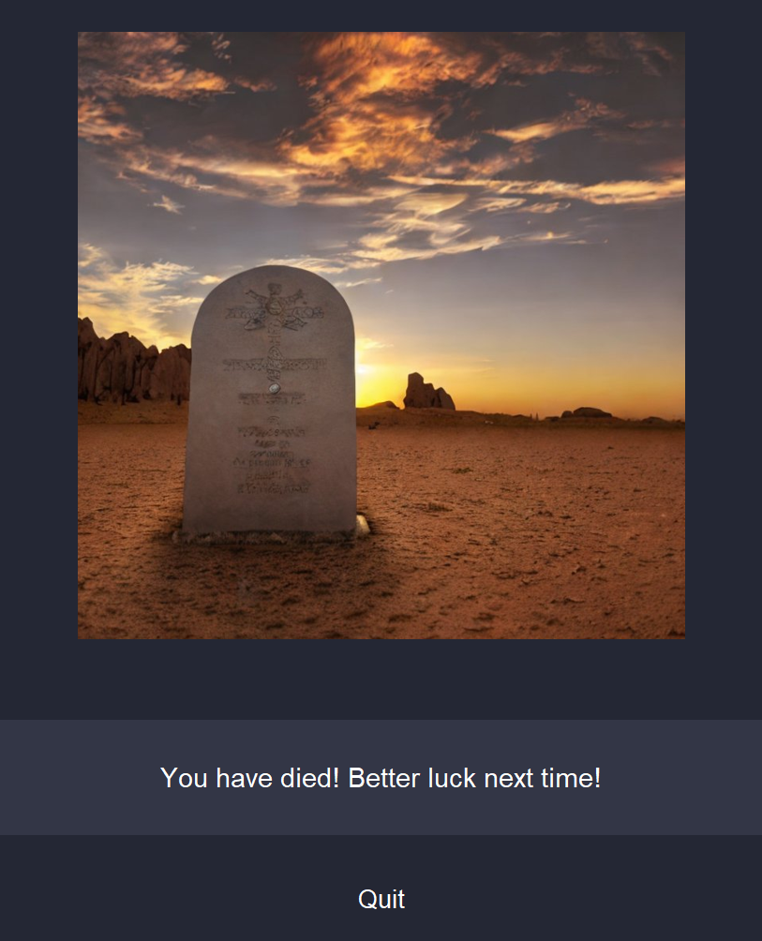

**Success:**

If luck is with you, you will reach the end of the trail alive and well to seek your fortunes.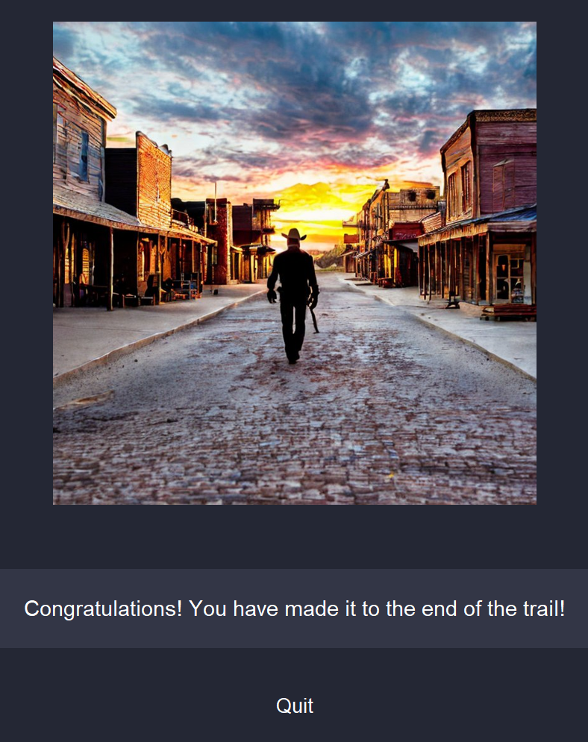

# **Summary**

The Oregon Trail with Python(s) is a game of resource management and luck. Each decision or scenario represents one day in the game. Randomization is used throughout the game to determine outcomes. Characters have different starting money, skills, and odds of success in special events. Money is used for purchasing food or special services. Time is tracked by a distance counter, which decreases randomly each day. Food is consumed daily, and you can buy additional food at certain checkpoints. Scenarios are randomly selected and can add or subtract time, food, or directly affect your survival. Hunting allows you to gather food but doesn't present additional scenarios. Success in scenarios depends on randomized outcomes and character abilities.